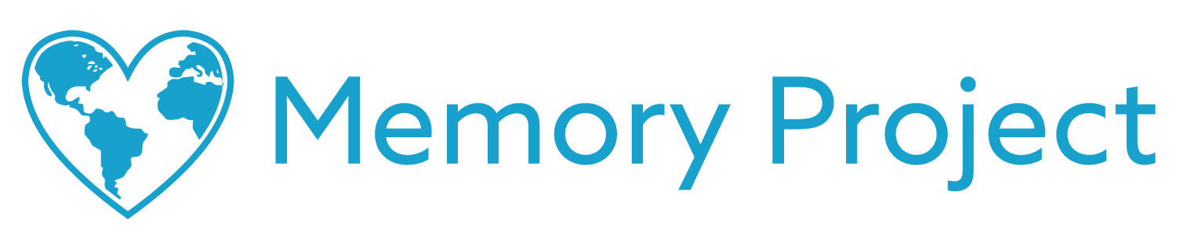

Dear [NAME HERE],

The Memory Project is a nonprofit organization dedicated to creating global kindness through art (memoryproject.org). This year we would love to have your school participate in our Poetry Exchange program where American students exchange heartfelt poems with children from countries that speak English or teach English in school.

The intent of the exchange is to promote intercultural awareness, break down cultural and geographical barriers, and inspire creativity through the personal art of poetry. The identities and locations of all children are kept strictly confidential (memoryproject.org/privacy).

All participants write their first name and age on the back of the poems, attach a photo of themselves, and trace an outline of their hand. This allows all participants to see the child with whom they are exchanging poetry, and to symbolically touch hands across the world.

Generally, we ask for a financial contribution of $12 per student to participate in this program. It is our only source of funding and goes towards the coordination and shipping costs of the exchange (see exactly how we use your contribution at memoryproject.org/poetryexchange-costs). We are happy to work flexibly with teachers to help as many students participate as possible.

To learn more about the Poetry Exchange and The Memory Project, feel free to visit memoryproject.org/poetryexchange. Please don’t hesitate to reach out to us at poetry@memoryproject.org with any questions.

Sincerely,
The Memory Project Team

2163 N. Gateway St.
Middleton, WI 53562
P) 608-616-0317
www.memoryproject.org

