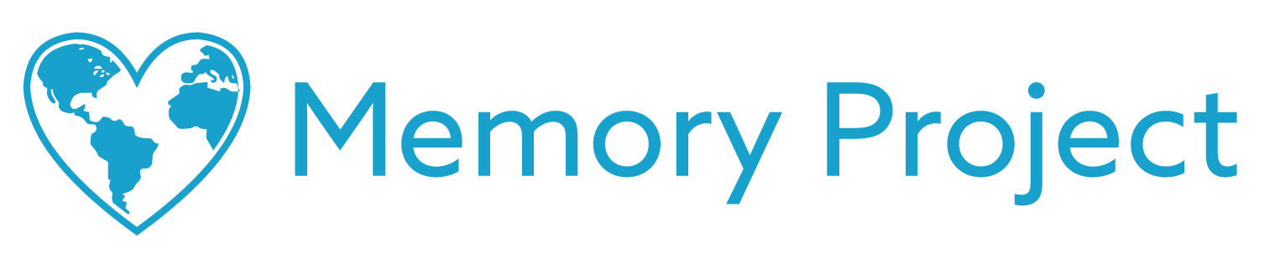

Dear [NAME HERE],

The Memory Project is a nonprofit organization dedicated to creating global kindness through art (memoryproject.org). This year we would love to have your school participate in our Global Art Exchange program where American students exchange heartfelt artwork with children from countries that are culturally very different from the USA.

The intent of the exchange is to promote intercultural awareness, break down cultural and geographical barriers, and inspire creativity through the universal language of art. The identities and locations of all children are kept strictly confidential (memoryproject.org/privacy).

All participants write their first name and age on the back of the artwork, attach a photo of themselves, and trace an outline of their hand. This allows all participants to see the child with whom they are exchanging art, and to symbolically touch hands across the world.

Generally, we ask for a financial contribution of $12 per student to participate in this program. It is our only source of funding and goes towards the coordination and shipping costs of the exchange (see exactly how we use your contribution at (memoryproject.org/artexchange-costs). We are happy to work flexibly with teachers to help as many students participate as possible.

To learn more about the Global Art Exchange and The Memory Project, feel free to visit (memoryproject.org/artexchange). Please don’t hesitate to reach out to Nora, our Global Art Exchange Coordinator, at art@memoryproject.org with any questions.

Sincerely,

Nora Feldman,
Art Exchange Coordinator
The Memory Project
2163 N. Gateway St.
Middleton, WI 53562
P) 608-285-2543

