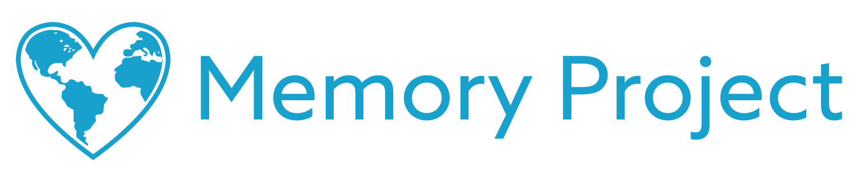

Dear Parents & Guardians,

The Memory Project is a nonprofit organization dedicated to creating global kindness through art (memoryproject.org). This year we are excited to have your child’s school participate in our Poetry Exchange program where American students exchange heartfelt poems with children from countries that speak English or teach English in school.

The intent of the exchange is to promote intercultural awareness, break down cultural and geographical barriers, and inspire creativity through the personal art of poetry. The identities and locations of all children are kept strictly confidential (memoryproject.org/privacy).

All participants write their first name and age on the back of the poems, attach a photo of themselves, and trace an outline of their hand. This allows all participants to see the child with whom they are exchanging poetry, and to symbolically touch hands across the world.

To learn more about the Poetry Exchange and the Memory Project, feel free to visit www.memoryproject.org/poetryexchange. Please don’t hesitate to reach out us at poetry@memoryproject.org with any questions.

Sincerely,

The Memory Project Team

2163 N. Gateway St.
Middleton, WI 53562
P) 608-616-0317
www.memoryproject.org

